**Lab Matplotlib more plots and formatting(Day-24)**

**Lab1: Analyze the relationship between the size of houses (measured in square**

**footage) and their selling prices in a particular neighborhood. You have collected**

**data on various houses in that neighborhood.Create a scatter plot using the**

**below data and share your conclusion/analysis.**

**Input:**

**square_footage = np.array([1200, 1400, 1600, 1800, 2000, 2200, 2400, 2600, 2800,**

**3000])**

**selling_prices = np.array([250, 290, 315, 380, 410, 450, 500, 525, 570, 610])**

**Output:**

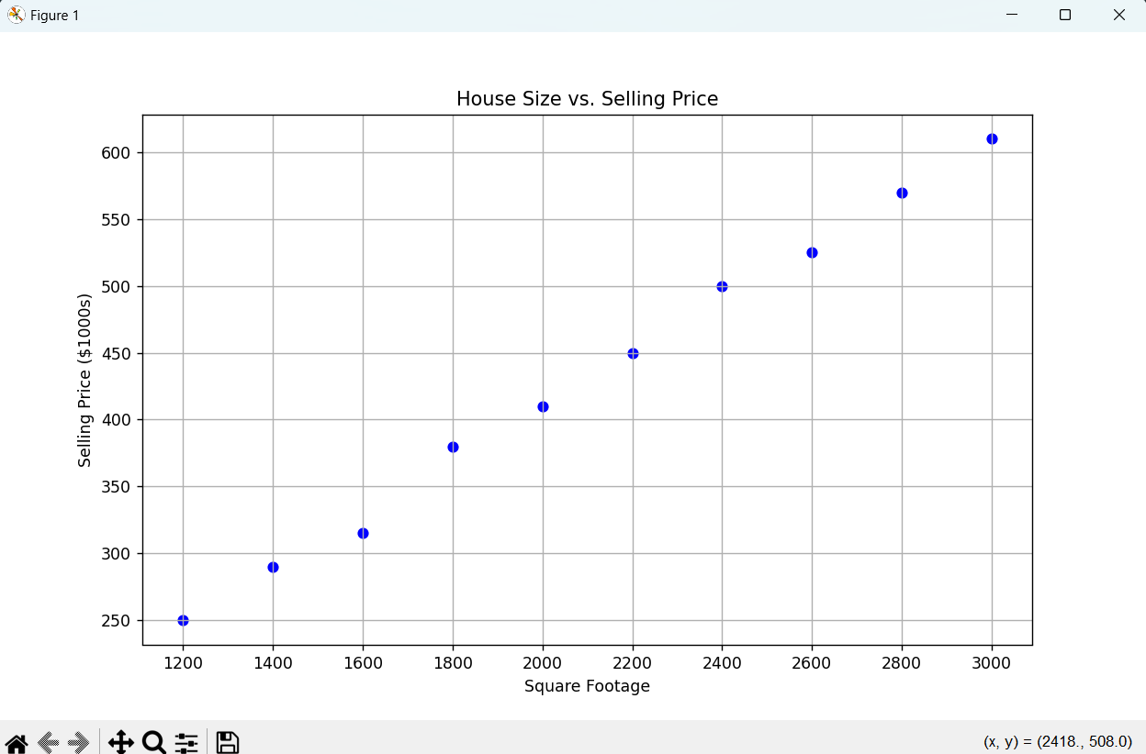

**Lab2: Create a pie chart to visualize the distribution of your monthly income by**

**source. You have collected data on the various sources of your income, such as**

**salary, freelance work, investments, and rental income. Share your**

**conclusion/analysis.**

**Input:**

**income_sources = ['Salary', 'Freelance', 'Investments', 'Rental', 'Other']**

**monthly_income = [5000, 1500, 1000, 600, 400]**

**Output:**

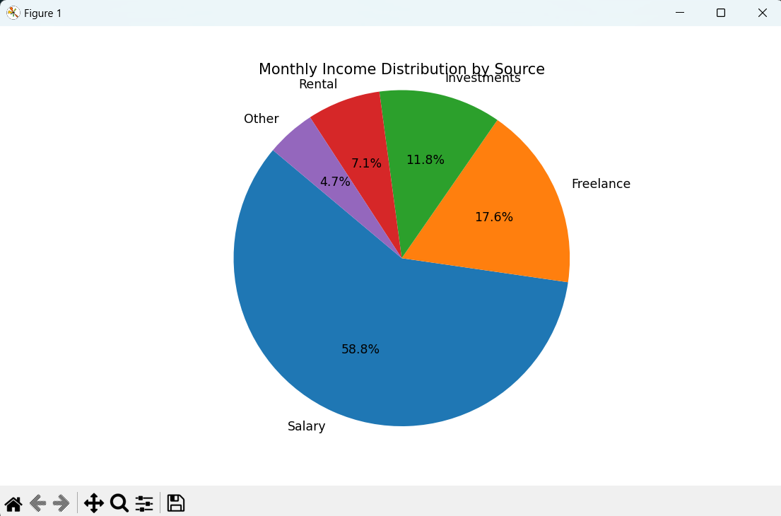

**Lab3: Create a pie chart to illustrate the distribution of a company's revenue**

**across its various business segments. You have collected data on the revenue**

**generated by each segment, such as Product A, Product B, Services, and**

**Licensing. Share your conclusion/analysis.**

**Input:**

**segments = ['Product A', 'Product B', 'Services', 'Licensing']**

**revenue_percentages = [45, 25, 15, 15]**

**Output:**

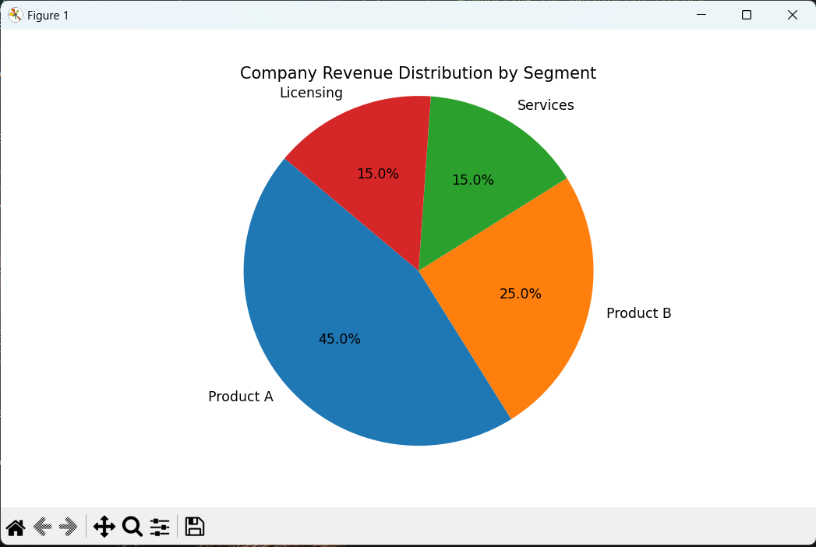

**Lab4: Suppose you're a sales manager for an e-commerce company, and you**

**want to create a figure with subplots to compare the sales performance of**

**different product categories over time. You have sales data for four product**

**categories: Electronics, Clothing, Home & Garden, and Sports & Outdoors. Share**

**your conclusion/analysis.**

**Input:**

**months = np.arange(1, 13)**

**electronics_sales = np.array([25000, 28000, 31000, 27000, 30000, 32000, 35000,**

**36000, 38000, 39000, 41000, 42000])**

**clothing_sales = np.array([15000, 16000, 17000, 18000, 19000, 20000, 21000, 22000,**

**23000, 24000, 25000, 26000])**

**home_garden_sales = np.array([18000, 19000, 20000, 21000, 22000, 23000, 24000,**

**25000, 26000, 27000, 28000, 29000])**

**sports_outdoors_sales = np.array([12000, 13000, 14000, 15000, 16000, 17000, 18000,**

**19000, 20000, 21000, 22000, 23000])**

**Output:**

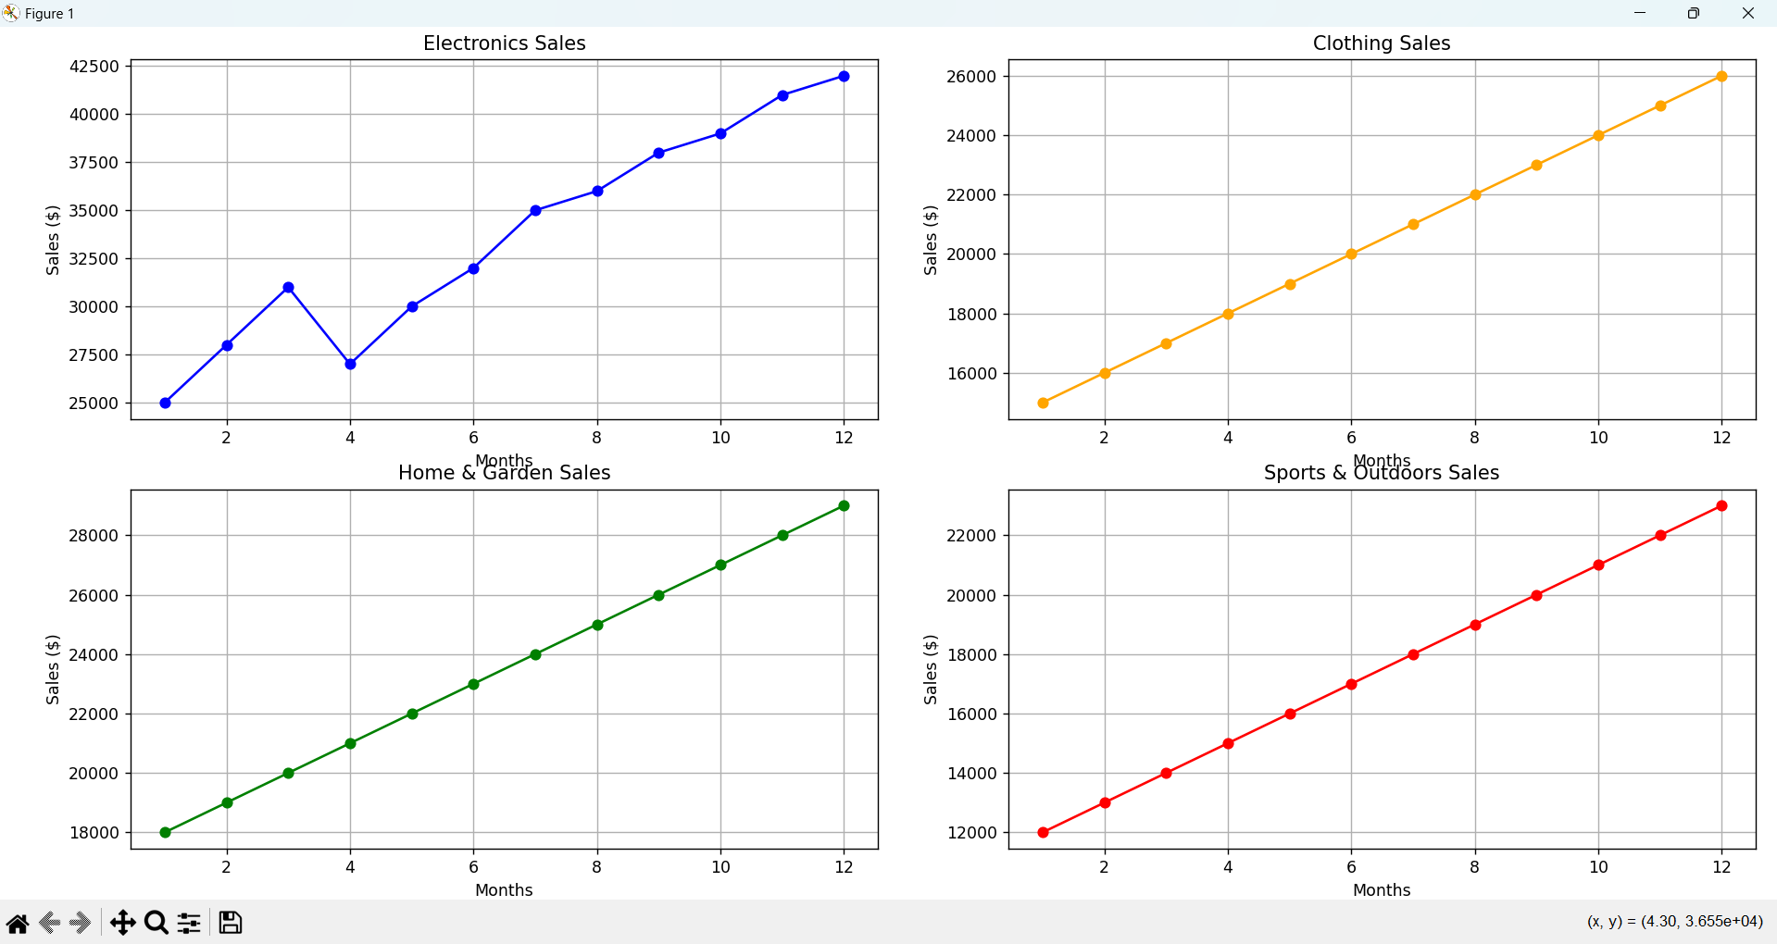

**ChatGPT Exercise**

**Using ChatGPT generate the python code to solve the same problem**

**Scenario:Analyzing Sales Data**

**Suppose you work for a retail company, and you have dummy data containing sales**

**data for the past year. The data includes information such as SalesDate,product**

**names,regions, sales quantities, prices, and dates. You have to generate a bar chart**

**,pie plot on region and prices and line chart on SalesDate and prices columns.**

**Further, you need to get some inference out of the chart.**

**Create a ChatGPT prompt to generate the code for this scenario. Based on the code**

**generated, ask ChatGPT to give the conclusion/inference.**

**Note. You can provide the data to ChatGPT or ask it to use sample data.**

**Output:**

**1.**

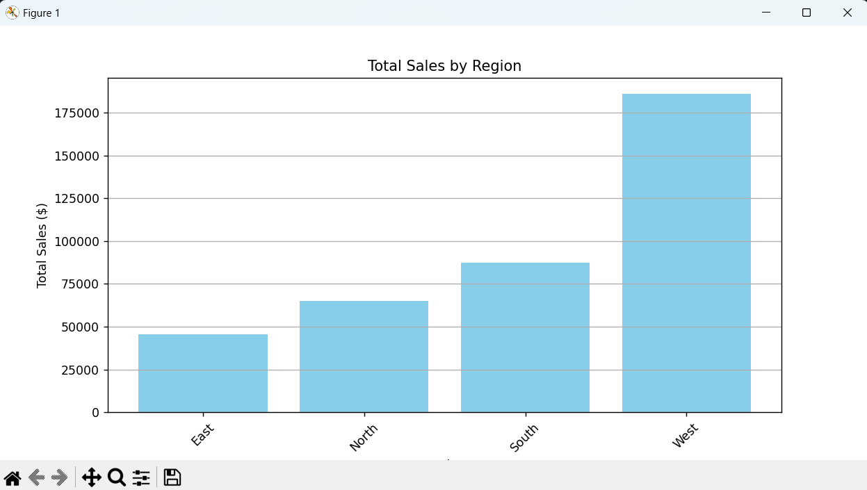

**2.**

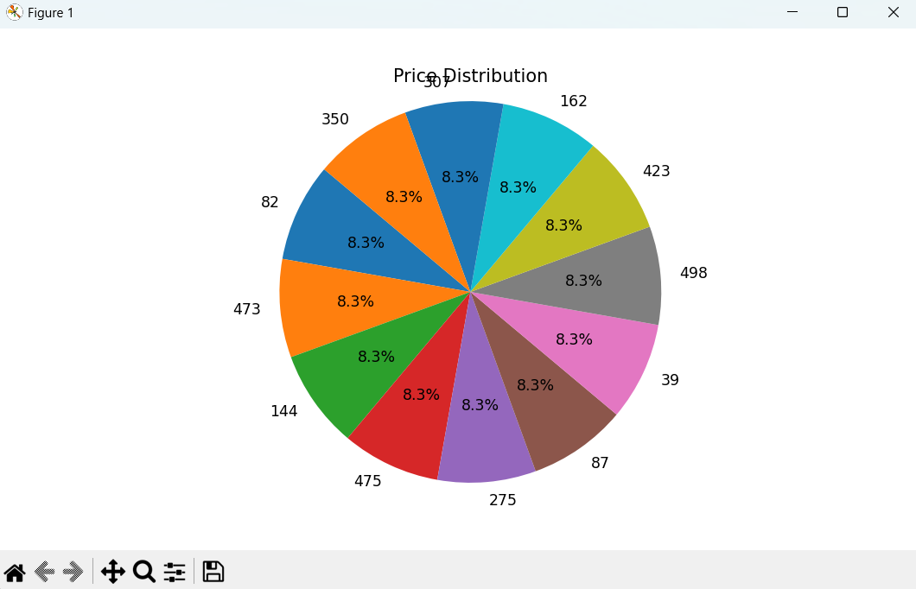

**3.**

